Practical-1

AIM: Installation of VS Code. Implement Linear Search and Binary Search using array data structure.

Program:

#include<bits/stdc++.h>

using namespace std;

int binary_search(int arr[],int l,int h,int key);

int binary_search(int l,int h,int arr[],int key);

void linear_search(int a[],int key,int n);

void search(int number);

void search(int number,int arr[],int key,int n,int l,int h,int a)

{

switch(number)

{

case 1:

linear_search(arr,key,n);

break;

case 2:

a=binary_search(arr,l,h,key);

if(a>0)

cout<<"Found";

else if(a<0)

cout<<"Not Found";

break;

case 3:

a=binary_search(l,h,arr,key);

if(a>0)

cout<<"Present";

else if(a<0)

cout<<"Not Present";

break;

}

}

void linear_search(int a[],int key,int n)

{

int flag=1;

for(int i=0;i<n;i++)

{

if(key==a[i])

{

flag=0;

break;

}

}

if(flag==1)

{

cout<<"Number is not Present in Array";

}

else if(flag==0)

{

cout<<"Number is present in array";

}

}

int binary_search(int arr[],int l,int h,int key)

{

int mid;

while(l<=h)

{

mid=(l+h)/2;

if(arr[mid]==key)

return mid;

else if(arr[mid]>key)

{

h=mid-1;

}

else

l=mid+1;

}

return -1;

}

int binary_search(int l,int h,int arr[],int key)

{

int mid;

mid=(l+h)/2;

if(l<=h)

{

if(arr[mid]==key)

return mid;

else if(arr[mid]>key)

binary_search(l,mid-1,arr,key);

else if(arr[mid]<key)

binary_search(mid+1,h,arr,key);

}

else

return -1;

}

int main()

{

cout<<"\nThis program is prepared by JHIL 22ce009\n";

int arr[30],l=0,n,key,number,a;

cout<<"Enter the size: ";

cin>>n;

int h=n-1;

for(int i=0;i<n;i++)

{

cout<<"arr["<<i+1<<"]: ";

cin>>arr[i];

}

cout<<"Enter your Key Element: ";

cin>>key;

cout<<"Enter 1 for Linear_Search"<<endl;

cout<<"Enter 2 for binary_search"<<endl;

cout<<"Enter 3 for Recursive binary_search"<<endl;

cout<<"Enter your number: ";

cin>>number;

search(number,arr,key,n,l,h,a);

cout<<endl;

cout<<"Enter the size: ";

cin>>n;

h=n-1;

for(int i=0;i<n;i++)

{

cout<<"arr["<<i+1<<"]: ";

cin>>arr[i];

}

cout<<"Enter your Key Element: ";

cin>>key;

cout<<"Enter your number: ";

cin>>number;

search(number,arr,key,n,l,h,a);

cout<<endl;

cout<<"Enter the size: ";

cin>>n;

h=n-1;

for(int i=0;i<n;i++)

{

cout<<"arr["<<i+1<<"]: ";

cin>>arr[i];

}

cout<<"Enter your Key Element: ";

cin>>key;

cout<<"Enter your number: ";

cin>>number;

search(number,arr,key,n,l,h,a);

return 0;

}

Output:-

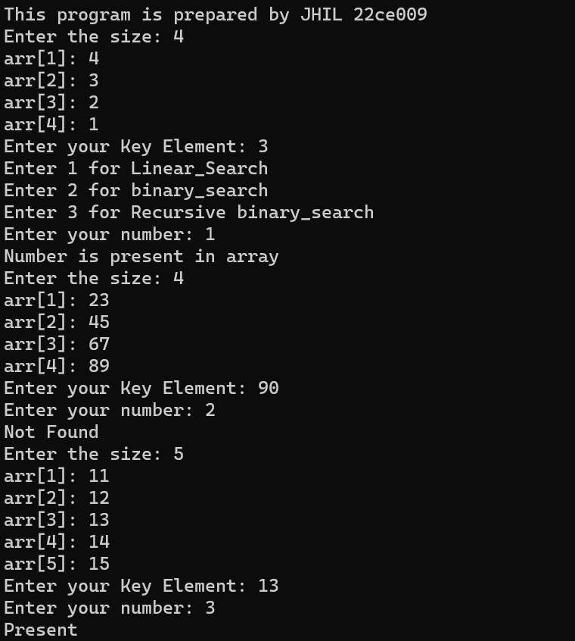

CONCLUSION:-

________ ________ _______

Student Signature Faculty Signature Marks